

Presented by
Sriyanjana Adhikary

Overview
  - What is DNS ??
  - DNS HIERARCHY
  - TYPES OF NAME SERVERS
  - WHAT IS DNS REPLICATION
  - WHAT IS RESOURCE RECORD ??
  - HOW TO ACCESS A WEB PAGE??
  - TYPES OF DNS QUERIES
  - DNS MESSAGE FORMAT
  - DNS CACHING
  - DNS CACHE SNOOPING

WHAT IS DNS ?
  - The domain name system is usually used to translate a host name into an IP address.
  - Domain names comprise a hierarchy so that names are unique, yet easy to remember.
  - The DNS is an elegantly designed distributed and fault-tolerant database.

  - single point of failure
  - traffic volume
  - distant centralized database
  - maintenance
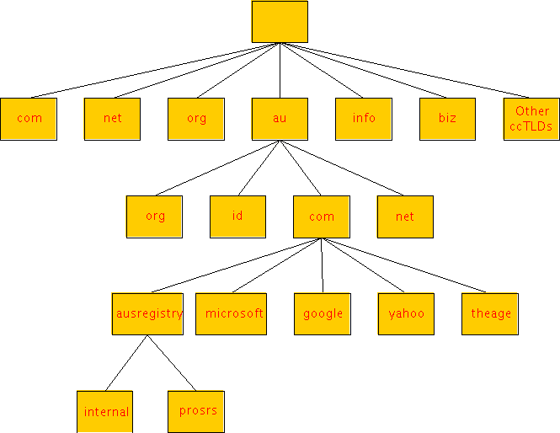
Naming a Domain Naming a Directory
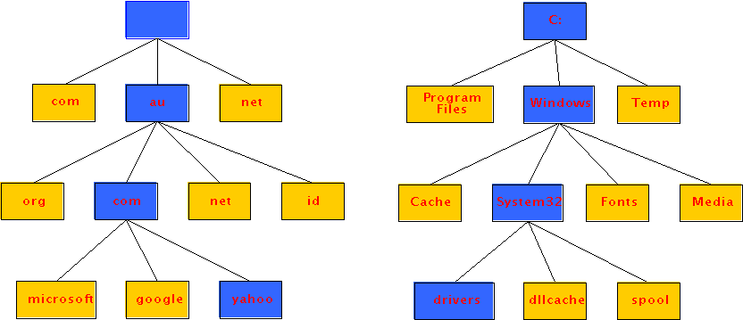



  - ROOT NAME SERVERS
  - TOP-LEVEL DOMAIN(TLD) NAME SERVERS
  - AUTHORITATIVE NAME SERVERS
  - LOCAL NAME SERVERS
  - contacted by local name server that can not resolve name.
Then the root name server:
    - contacts authoritative name server if name mapping not known
    - gets mapping
    - returns mapping to local name server
13 ROOT NAMESERVERS

  - Top-level domain (TLD) servers: responsible for com, org, net, edu, etc, and all top-level country domains uk, fr, ca, jp.
    - Network solutions maintains servers for com TLD
    - Educause for edu TLD
  - Authoritative DNS servers: organization’s DNS servers, providing authoritative hostname to IP mappings for organization’s servers (e.g., Web and mail).
    - Can be maintained by organization or service provider
DNS Replication
For every domain, we need more than one authoritative nameserver with the same information (RFC 2182)‏
Data is entered in one server (Master) and replicated to the others (Slave(s))‏
Outside world cannot tell the difference between master and slave.
NS records are returned in random order for equal load sharing
Used to be called "primary" and "secondary"

Slaves connect to Master to retrieve copy of zone data
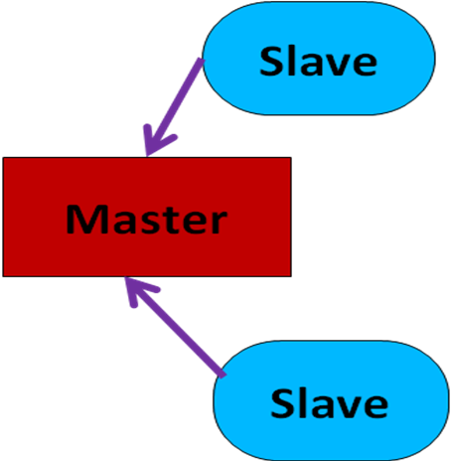The master does not "push" data to the slaves
Configuration of Master
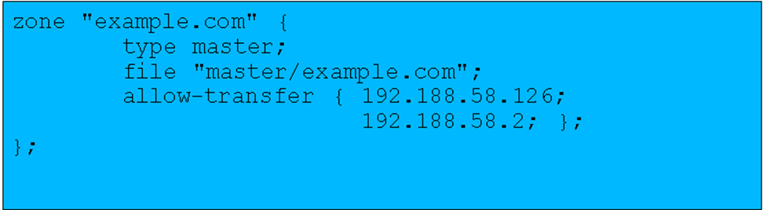
Configuration of Slave



  - Each ISP (residential ISP, company, university) has one.
    - Also called “default name server”
  - When a host makes a DNS query, query is sent to its local DNS server
    - Acts as a proxy, forwards query into hierarchy.
    - Reduces lookup latency for commonly searched hostnames by introducing the concept of cache.
Resource Record
- Domain Name :
Domain Name tells the domain to which these records applies.
- Time_to_live :
This field gives an indication of how stable the record is. Information that is highly stable is assigned a large value, such as 86400. Information that is highly volatile is assigned a small value,such as 60.
- Class :
This field classifies whether the resource record is internet information or non-internet information. For internet information it is always IN, other codes can be used for non-internet information.
- Value :
This field can be a number, a domain name or an ASCII string. The semantics depend on the record type.
- Type :
The 'Type' field tells what kind of record this is.

Type | Meaning | Value
SOA | Start of Authority | Parameters for this zone
A | ip address of a host | 32-bit integer
MX | Mail exchange | Priority,domain willing to accept e-mail
NS | nameserver | Name of a server for this domain
CNAME | Cannonical name | Domain Name
PTR | Pinter | Alias for an Ip address
HINFO | Host description | Cpu and os in Ascii
TXT | Text | Uninterpreted ascii text

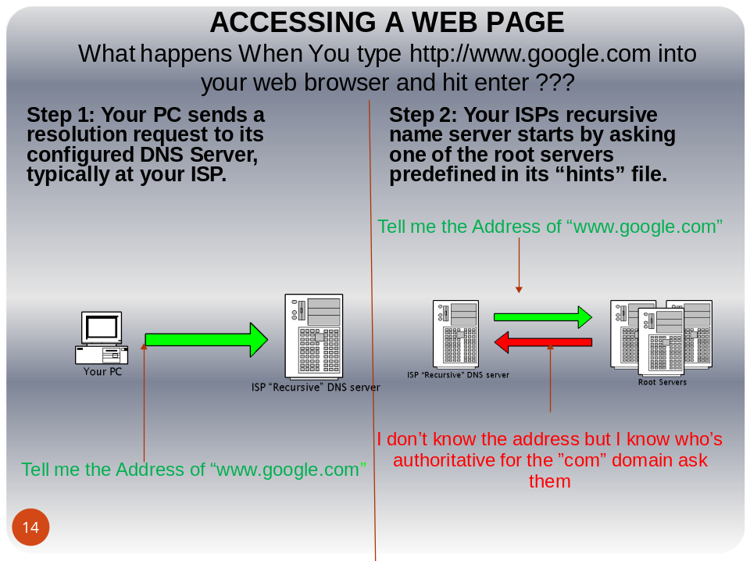

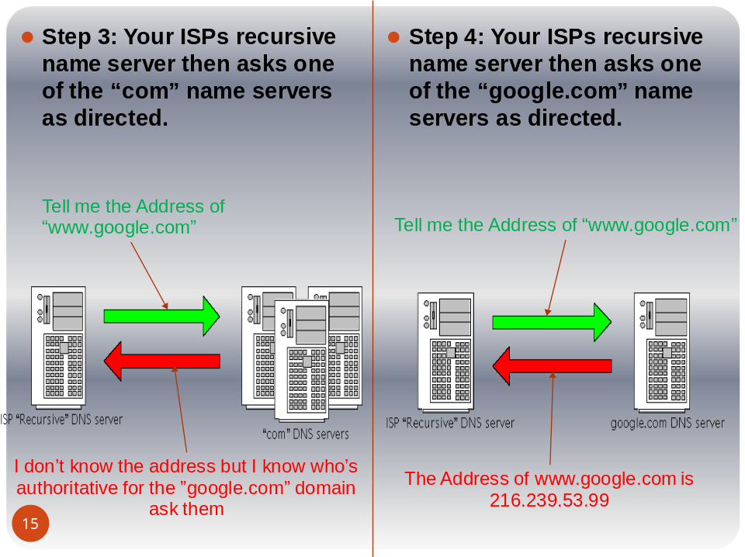

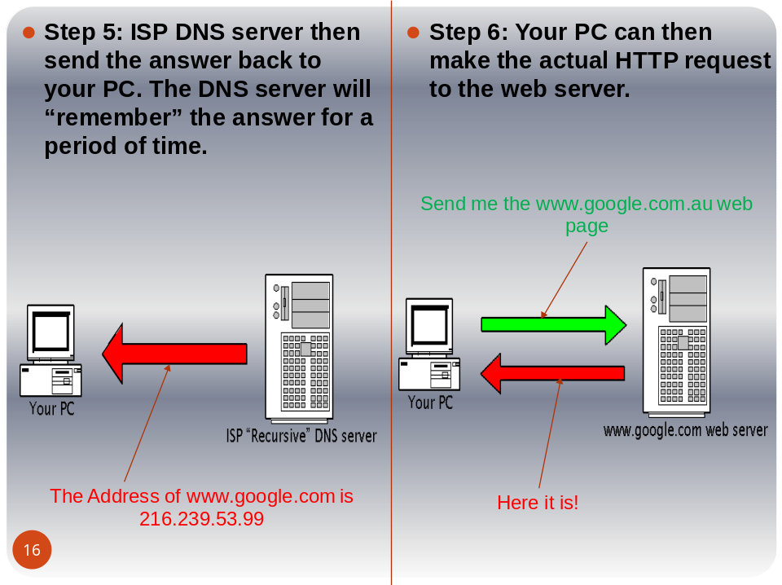

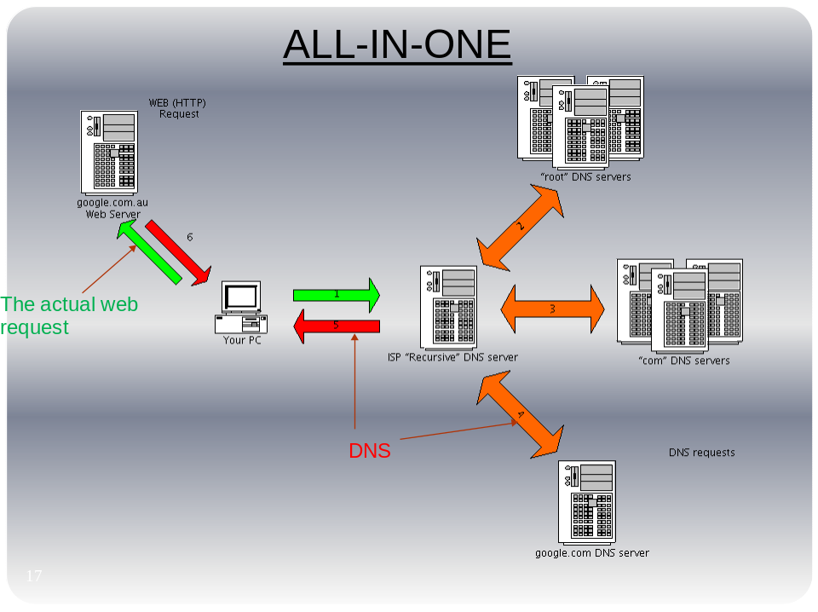


  - There are two types of queries:
    - Recursive queries
    - Iterative (non-recursive) queries
  - The type of query is determined by a bit in the DNS query
  - Recursive query: When the name server of a host cannot resolve a query, the server issues a query to resolve the query
  - Iterative queries: When the name server of a host cannot resolve a query, it sends a referral to another server to the resolver

  - In a recursive query, the resolver expects the response from the name server
  - If the server cannot supply the answer, it will send the query to the “closest known” authoritative name server (here: In the worst case, the closest known server is the root server)‏
  - The root server sends a referral to the “edu” server. Querying this server yields a referral to the server of “virginia.edu”
  - … and so on

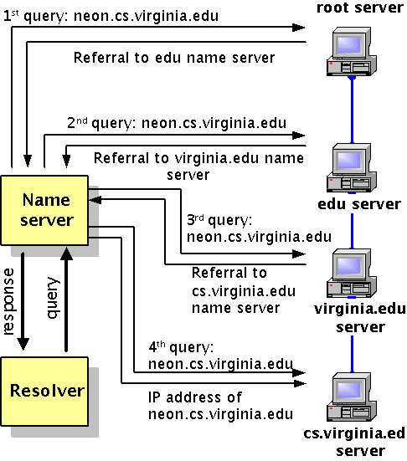

  - In an iterative query, the name server sends a closest known authoritative name server a referral to the root server.
  - This involves more work for the resolver
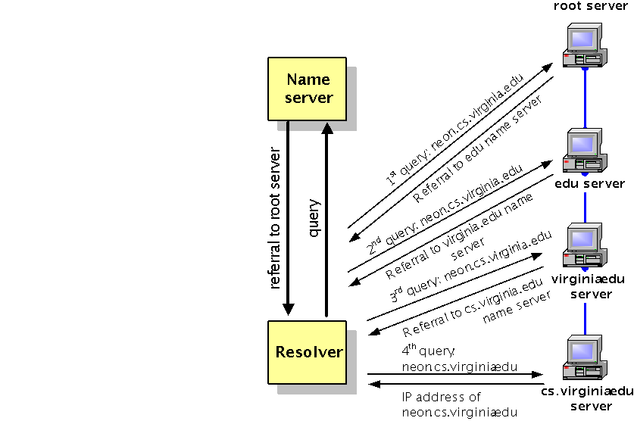
DNS Message Format

DNS CACHING
  - Caching can substantially reduce overhead
    - The top-level Domain servers very rarely change
    - Popular sites (e.g., www.google.com) visited often
  - Once (any) name server learns mapping, it caches mapping
    - cache entries timeout (disappear) after some time
    - TLD servers typically cached in local name servers
      - Thus root name servers not often visited
- The resolver/server model (diagram)
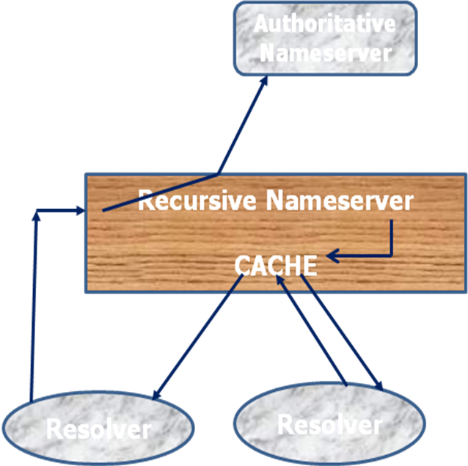

DNS CACHE SNOOPING
DNS cache snooping is the process of determining whether a given Resource Record (RR) is (or not)present on a given DNS cache. There are two ways of accomplishing this, and they are presented as
follows.

The Technique – The Ecological Way (Non-recursive Queries)
$ dig @ns1.tvcabo.pt www.sidestep.pt A +norecursive
; <<>> DiG 9.2.2 <<>> @ns1.tvcabo.pt www.sidestep.pt A +norecursive
;; global options: printcmd
;; Got answer:
;; ->>HEADER<<- opcode: QUERY, status: NOERROR, id: 10698
;; flags: qr ra; QUERY: 1, ANSWER: 0, AUTHORITY: 7, ADDITIONAL: 7
;; QUESTION SECTION:
;www.sidestep.pt. IN A
;; AUTHORITY SECTION:
pt. 66823 IN NS ns.dns.pt.
pt. 66823 IN NS ns2.dns.pt.
;; ADDITIONAL SECTION:
ns.dns.pt. 11611 IN A 193.136.0.1
ns2.dns.pt. 7154 IN A 193.136.2.226
;; Query time: 3 msec
;; SERVER: 212.113.161.227#53(ns1.tvcabo.pt)
;; WHEN: Fri Jan 4 17:31:59 2004
;; MSG SIZE rcvd: 312

Note the following output, produced by the same command:
$ dig @ns1.tvcabo.pt www.sidestep.pt A +norecursive
; <<>> DiG 9.2.2 <<>> @ns1.tvcabo.pt www.sidestep.pt A +norecursive
;; global options: printcmd
;; Got answer:
;; ->>HEADER<<- opcode: QUERY, status: NOERROR, id: 52370
;; flags: qr ra; QUERY: 1, ANSWER: 1, AUTHORITY: 0, ADDITIONAL: 0
;; QUESTION SECTION:
;www.sidestep.pt. IN A
;; ANSWER SECTION:
www.sidestep.pt. 28772 IN A 193.126.14.52
;; Query time: 4 msec
;; SERVER: 212.113.161.227#53(ns1.tvcabo.pt)
;; WHEN: Sun Jan 4 18:35:22 2004
;; MSG SIZE rcvd: 49
The Technique – The Polluting Way (Recursive Queries)
$ dig @ns1.tvcabo.pt www.sidestep.pt A +recursive
; <<>> DiG 9.2.2 <<>> @ns1.tvcabo.pt www.sidestep.pt A +recursive
;; global options: printcmd
;; Got answer:
;; ->>HEADER<<- opcode: QUERY, status: NOERROR, id: 44516
;; flags: qr rd ra; QUERY: 1, ANSWER: 1, AUTHORITY: 0, ADDITIONAL: 0
;; QUESTION SECTION:
;www.sidestep.pt. IN A
;; ANSWER SECTION:
www.sidestep.pt. 6458 IN A 193.126.14.52
;; Query time: 13 msec
;; SERVER: 212.113.161.227#53(ns1.tvcabo.pt)
;; WHEN: Mon Jan 5 00:47:17 2004
;; MSG SIZE rcvd: 49
Note the following output, produced by the same command:
$ dig @ns.sidestep.pt www.sidestep.pt A
; <<>> DiG 9.2.2 <<>> @ns.sidestep.pt www.sidestep.pt A
;; global options: printcmd
;; Got answer:
;; ->>HEADER<<- opcode: QUERY, status: NOERROR, id: 53517
;; flags: qr aa rd; QUERY: 1, ANSWER: 1, AUTHORITY: 2, ADDITIONAL: 1
;; QUESTION SECTION:
;www.sidestep.pt. IN A
;; ANSWER SECTION:
;www.sidestep.pt. 86400 IN A 193.126.14.52
;; AUTHORITY SECTION:
sidestep.pt. 259200 IN NS ns.sidestep.pt.
sidestep.pt. 259200 IN NS www.sidestep.pt.
;; ADDITIONAL SECTION:
ns.sidestep.pt. 86400 IN A 193.126.14.51
;; Query time: 1 msec
;; SERVER: 193.126.14.51#53(ns.sidestep.pt)
;; WHEN: Mon Jan 5 00:59:06 2004
;; MSG SIZE rcvd: 96


  - http://www.livinginternet.com/i/iw_dns.htm
  - http://www.centr.org
  - Domain Names - Concepts and Facilities, P. Mockapetris
  - Role of the Domain Name System (DNS)-O'Reilly S
  - Snooping the Cache for Fun and Profit
Version 1.1 / February 2004
Luis Grangeia

